**Brooklyn torah gazette**

**For parshas mishpatim 5781**

Volume 5, Issue 24 (Whole Number 224) 1 Adar 5781/ February 13, 2021

**Printed L’illuy nishmas Nechama bas R’ Noach, a”h**

For a free subscription, please forward your request to [***keren18@juno.com***](mailto:keren18@juno.com)

Past emails can be found on the website **ShabbosStories.com**

**R’ Yosef ibn Aknin z”l**

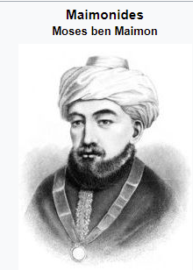

R’ Yosef ibn Aknin z”l (born approx.1160 – died 1226) R’ Yosef ben Yehuda ibn Aknin was the person for whom Rambam wrote his Moreh Nevochim/Guide to the Perplexed. R’ Yosef was born in Ceuta, Morocco, but fled from there due to Moslem oppression.

He first settled in Alexandria, Egypt, where he began corresponding with Rambam, and later, the great sage invited R’ Yosef to Cairo to study with him. When Rambam saw that R’ Yosef was troubled by the conflict between philosophy and the teachings of the Prophets, Rambam wrote Moreh Nevochim to resolve his student’s doubts.

In 1186, R’ Yosef moved to Aleppo, Syria, where he practiced medicine. He continued his correspondence with Rambam, and many of these letters are still extant. (Some of these letters refer to the attacks of other rabbis on Rambam. In them, Rambam explains that he is above caring about his personal reputation, especially when his attackers are unworthy of a response.)

In response to the attacks of R’ Shmuel ben Eli of Baghdad on Rambam’s Mishneh Torah, R’ Yosef wanted to move to Baghdad and open a yeshiva where he would defend his teacher’s views. However, Rambam dissuaded R’ Yosef from giving up his medical practice and trying to earn a living as a rosh yeshiva.

After Rambam’s death, R’ Yosef asked Rambam’s son, R’ Avraham, to excommunicate R’ Daniel Ha’Bavli (the leading student of R’ Shmuel be Eli) for his slights to the Rambam’s honor, but R’ Avraham declined. R’ Yosef wrote a number of works, including a halachic work (in Arabic) and commentaries on Pirkei Avot and Shir Ha’shirim. (The Artscroll Rishonim; Iggeret Ha’Rambam Le’Rav Yosef)

*Reprinted from the Parshas Mishpatim 5781 email of whY I Matter parsha sheet of the Young Israel of Midwood in Brooklyn compiled by Reb Yedidye Hirtenfeld.*

# Rav Avigdor Miller on Carter’s Inauguration

# And Reagan’s Election

**QUESTION:** **What do you think about the election of Carter to be our next President?**

**ANSWER: I** haven’t the slightest knowledge about Carter. But I hope that Hakodosh Boruch Hu will give Him His blessings and give him success. Now that he’s been elected, it’s a mitzvah to daven for Carter.

It’s a mitzvah. You have to be mispallel b’shlom malchus; every Jew has to pray for the benefit of the government. Now that he’s been elected we daven he should be well; he shouldn’t catch a cold. He shouldn’t be bothered by the liberals. He shouldn’t have any wars in his time. And בימיו תושע יהודה וישראל ישכון לבטח (Yirmiyahu 23:6), in his time the Jewish people should be happy and prosperous and Moshiach should come. That’s the best I can tell you.

**A Duty to Pray for Carter’s Success**

And that’s our duty, to pray for Carter. Every Jew has to pray for Carter. And you have to still pray for Ford by the way, because he’s still President until January. So for the duration of his term you have to pray for him.

A Jew must pray for his government. It’s very important. It’s a mishna in Mesichta Avos (3:2); plain and simple we must pray for the government. And even if you haven’t done it till now, it’s a good time to begin. From now on think about it sometimes, and say it. Even when you’re on the street walking, say a little prayer for the President and for the Vice-president, and don’t be ashamed. Don’t worry that you might be ridiculed by somebody – let nobody know about it. But you should know that you’re doing the duty of an Orthodox Jew.

You must pray for the government! Not because you want to show the government that you pray for them. The fakers come together and wave flags, and they make an official prayer – that doesn’t mean a thing. They’re not praying for the government, they’re just showing off. Pray for the government quietly between yourself and Hashem.



**Rabbi Avigdor Miller, zt”l**

**Desire that Carter Should be Well and Not Have Troubles**

And you should really mean it. Have in mind that Carter should be well and that he shouldn’t have troubles. He shouldn’t fight with his wife. He should have peace at home and peace in the government. Congress should cooperate with him. There’s no question that if there will be a tranquil government, then Carter will try to make a good name for himself. No question about it. Any President would like to make a regime that will go down in history as a successful regime.

And so, our best wishes are given to the incumbent, President-elect Carter, and Hakodosh Boruch Hu should help him –  and us.  
TAPE # 144 (November 1976)

**FROM TAPE 337 (November 1980; after the election of President Reagan)**  
**“The American nation has finally shown that we disapprove of these wicked liberals. This last election, a landslide, really was a revolution against the crazy liberals! And it’s time we threw them out of the city governments and state governments too; we have to get rid of them everywhere because they are ruining America.**

**They are the ones because of whom crime is flourishing. They are the ones that caused America to be now a second-rate country and the Communists are taking over everywhere in the world – even in Central and South America. That’s why Russian airplanes now fly over American cities. You know there’s a Russian airplane station in Cuba and they overfly the Floridian cities and no one can say anything to them. Soon they’ll be near Washington.**

**And if President Carter would have continued in office there could have been Russian tanks in Washington D.C. and he would have send a telegram to the Russians: “What are you doing with your Russian tanks on Pennsylvania Avenue?! I’m going to stop sending the next shipment of Pepsi Cola to you if you keep this up.” It’s only due to these crazy people that the world is upside-down.**

***Reprinted from the January 21, 2021 email of Toras Avigdor.***

**Thoughts that Count for Parshat Mishpatim**

*And these are the ordinances which you shall set before them* (Exodus 21:1)

"Before them" in every sense of the word: the Jewish people must be made to realize that My commandments are of primary concern and importance. *(Rabbi Bunim of Pshischa)*

*Keep far away from falsehood* (Exodus 23:7)

A liar is more despicable than either a robber or a thief: The robber steals only at night, for he worries about being discovered. The thief steals by night and by day, but only from individuals, as he is afraid to confront a larger group. The liar, however, lies by night and by day, and spreads his falsehoods and gossip about everyone. *(The Magid of Kelem)*

***Reprinted from the Parshat Mishpatim 5756/1996 edition of L’Chaim Weekly.***

**Haste Makes Waste**

**By Rabbi Moshe Meir Weiss**

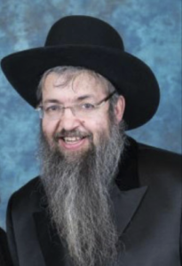

**Rabbi Moshe Meir Weiss**

Once again, as in the previous two columns, I’d like to share with you another piece of sage advice from the ancient book of wisdom, Orchos Chaim l’HaRosh. The Rosh teaches us to consider the consequences of any course of action before embarking upon it and he eloquently adds the verse , “V’hachochom einov b’rosho – And the wise man has his eyes in his head.”

At first glance, this seems to be an absurdity.  Everyone has their eyes in their head; it’s not solely the anatomy of one who is wise. But, here is what the Rosh means. Most people react immediately to what they see. The wise person responds to what he thinks about what he saw. So it is only the man of wisdom whose eyes are in their head. The Rosh advises us to take this precaution, not be hasty with our reactions.

When Yaakov was on his deathbed, he told Reuven, “You were the first of my strength and as such you were slated to have both the monarchy and the priesthood. However, ‘Pachas k’mayim, al toser – You were hasty like water,’ and therefore you will not excel.” Just like if a dam ruptures, the water does not ponder whether it should rush out and cause a flood. Rather it bursts out without any concern. So too, since Reuven acted impetuously, he lost all privileges of leadership.

The Rosh is guiding us to always consider the consequences of our actions before making a move. This is the trait of the wise. As it says, Eiza hu chacham? Haroeh es hanolad – Who is the wise man? He who can see the results of his actions.” The fool behaves according to his instincts and chooses the path of immediate gratification.

The Rosh cautions us not to be rash but rather to look before we leap.  So, for example, when couples argue, one of the spouses can say something that will ‘win’ the fight but then he will be stuck with the ‘loser’ the entire evening.  Not a pleasant prospect.  With a modicum of foresight, one can react in a more conciliatory manner and save a nighttime of unhappiness.

Similarly, a parent might scream at a child in frustration and, while the ability to vent affords temporary relief, the loss of the child’s respect or the damage to the tranquility of the home can have long lasting detrimental effects.  As well, a nasty retort to a friend can give one a fleeting sense of relief but the damage of such a comment will linger in his colleague’s memory banks for decades.

So too, in the financial arena, hasty risks can embroil one in years of regret. In public school, they do a drill with kindergarten children. They give them a choice of three M&Ms now or a handful a week from now. Most children opt for the immediately available three. They are not able to look ahead.

Successful life in Yiddishkeit is all about considering the consequences.  Lashon hara leads to Gehenom. Giving away our hard earned money, to a charitable cause, leads to Gan Eden. Choosing a spouse solely because she has a beautiful face or because he has a bulging financial portfolio, is possible recipe for marital disaster.  Thus, we should try to train ourselves to think before we speak and to consider the consequences before we react.  If we are retorting and responding in anger or in a bad mood, it is oh so true that “Haste makes waste.”

Perhaps this is one of the reasons that the Torah defines the location of the Teffilen on one’s head as, “Ltotafos bein einecha- Frontlets between the eyes”. Of course we know this means that this is on the area of the front of the head that is parallel to between the eyes. Why does the Torah describes the location as between the eyes? Perhaps it is teaching us that when we see with our eyes we should think with our head!

As we get in the habit of “seeing with the eyes in our head,” we will find that soon it will become second nature for us to consider our options carefully, especially before any important endeavor.  In the merit of doing so, may Hashem bless us with long life, good health, and everything wonderful.

*Reprinted from the archives of the Matzav.com website of June 6, 2016*

**Rabbi Berel Wein on**

**Parshat Mishpatim 5781**

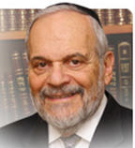

After the granting of the Torah to the Jewish people at Mount Sinai, this is followed with a long and detailed list of instructions, commandments, and laws. The mere existence of such a list presupposes the willingness of the population to follow these laws and instructions.

As we are all aware, because of the ongoing incidents that mark our attempt to deal with the current corona virus crisis, that there has to be an internal discipline amongst the people to have them obey any set of laws, no matter how wise and beneficial they may be, in order for the rule of law to be effective.

It has been estimated that over two-thirds of the laws passed by the Israeli Knesset over the past 72 years have never been enforced and are known, if at all, to exist only in the breach. There are not enough police in the world to enforce all the laws that every society has promulgated and advanced. Even in the most rigorous of dictatorships and the most controlled of societies, black markets flourish, crime is rampant and, in fact, the tighter the controls, the more ingenious people become in their methodology of defying and circumventing those laws they feel unfair or unnecessary.

The most disciplined of societies such as Japan, Switzerland, or perhaps even Germany are of that nature simply because of their social compact one with another. The brute force of police may achieve the appearance of obedience to the law and the government but eventually all of history teaches us that subsystems collapse simply because of the weight of the necessary enforcement involved.

The Torah also presupposes that there be a legal system and that judges and police are necessary adjuncts to any civilized society. However, the Torah also realizes that it is only by voluntary acceptance of discipline and obedience to laws, the concern for the public and its welfare, the understanding that one is responsible for the Jewish people as a whole and to the God of Israel for one's actions, to make the system of laws that we read about in this week's portion of the Torah workable, acceptable and, in fact, eternal.

If the people are unwilling to follow the rules, there are not enough policeman in the world that will make them, no matter how severe the penalty may be for disobedience and violations of the law.

The Torah records for us once again the response of the Jewish people when offered the Torah: “We will do and obey and then we will listen and understand.” Without that stated pledge to voluntarily observe the laws and precepts given them at Mount Sinai, there is no method available to human societies to enforce such a rigorous social and spiritual discipline to such a large population of individuals.

It is hoped that through study and education this voluntary acceptance, of the laws of the Torah, that has been hallowed by millennia of tradition and observance, will continue to govern Jewish society and its value system and behavior.

*Reprinted from the current website of Rabbiwein.com*

**More Thoughts for Parshat Mishpatim**

His master shall bore his ear through with an awl (martze'a) (Exodus 21:6)

Why a "martze'a?" Because its numerical equivalent is 400 -- the same number of years the Jewish people were originally supposed to be enslaved in Egypt.

When G-d took the Jews out of Egypt, He declared, "The Children of Israel shall be servants unto Me." Subsequently, anyone who willingly chooses to serve a human master rather than G-d deserves to have his ear bored through...*(Daat Chachamim)*

***Reprinted from the Parshat Mishpatim 5756/1996 edition of L’Chaim Weekly.***

**Parshas Mishpatim**

**The Effect of an Action**

**By Rabbi Bentzion Shafier**

**Founder of TheSmuz.com**

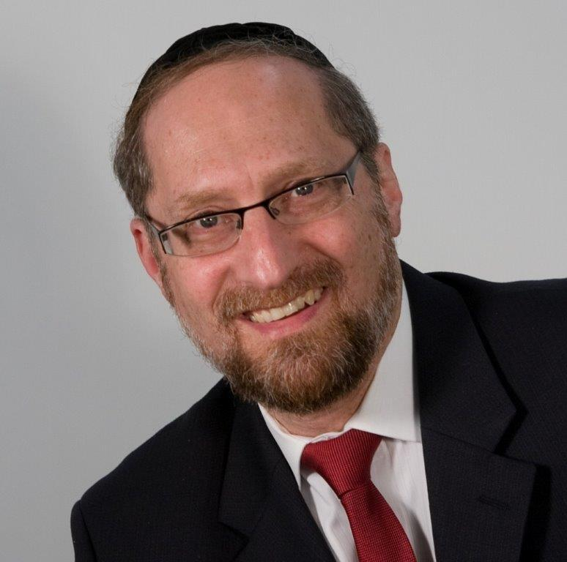

“*Holy people you shall you be to Me: you shall not eat flesh of an animal that was torn in the field; to the dog you shall throw it*.” — Shemos 22:30

The Torah tells us that if a sheep or goat is killed while grazing, it is called a treifa and should be given to the dogs to eat. Rashi explains that this is a **reward** for what the dogs did. When the Jewish People left Mitzraim, not a single dog barked. Since that was a kiddush HASHEM, for generations all treifas are to be fed to the dogs in repayment for what they did.

**How can a dog be entitled to reward?**

This Rashi is difficult to understand as we are dealing with animals. Animals are instinctual in their reactions. Granted, they can be trained to act in a particular manner, but they don’t have a conscious “I” that can weigh the different options and decide to act or not to act. They don’t have free will. In all of the physical Creation, only man was given that capacity. So how can a dog receive reward for its actions?

**Understanding reward and punishment**

One of the most basic tenets of our belief system is that nothing happens by chance. HASHEM created, maintains, and orchestrates this world. In truth, man can accomplish nothing in this world. Every action and every outcome is determined and controlled by HASHEM.

If Reuvain was predestined to live to be 120, I can neither harm him nor help him. HASHEM will insure that His decree is fulfilled – and there is nothing that I can do to change it. Man is in effect powerless. This leaves him in a circumstance of being able to accomplish very little on this planet. The outcomes are already set.

To allow for reward and punishment, HASHEM created a system whereby it is considered as if man determined the outcome. If I am the one acting on the scene, the result is attributed to me. It is credited to my account even though that outcome was inevitable – because HASHEM had so planned it.

In our case above, if Reuvain received a judgment on the previous Rosh Hashanah that his time was in fact up, then he will die this year, whether by my hands or through some other cause. However, I might well be permitted to be his murderer. It might come about that I will be allowed to pull the trigger on a gun, and from that shot he will die.

If this occurs, I will be held accountable. I am considered the one who killed him, even though his death was decided long before I picked up the gun. If I weren’t on the scene, he would have been hit by a car or a falling tree, but because of my choice, I am considered the one who did the act. I was allowed to become his murderer. And as such, I am responsible for his death.

So too, if someone intended to help Shimon and succeeded, we understand that good was coming to Shimon because HASHEM decided long ago. That is what he deserved. Had that individual not been on the scene, that same good would have come to Shimon through any one of many vehicles that HASHEM uses to run this world. Nevertheless, since that service came through the hands of an individual, that person is credited with the act. It is considered as if he did it.

**Through the dogs a greater kiddush HASHEM came about**

The answer to Rashi seems to be that via the dogs, there was a greater kiddush HASHEM. Everyone, both the Mitzrim and the Jews, saw a greater revelation of HASHEM’s hand because as an entire nation walked out, not an animal stirred. Through the animals a greater good was brought, and for that they deserve reward. Granted they didn’t intend it — they are animals — but through them came a good, and that is attributed to them. For that, they deserve reward.

There is a tremendous lesson for us in this concept. Every action that we perform affects others. If, in my business dealings, I act in a scrupulously honest manner and another Jew sees this and he then adopts that practice, I am given credit for his increased honesty. That is true even if he long ago forgot that I was the source of his change. Even though I didn’t intend it and may not be aware of it, through my actions he changed, so I am considered responsible for that difference. Everything that he does because of this impression is attributed to me.

The ramifications of this concept are astounding. On the good side as well as on the bad, whatever we do affects ourselves and others. If I act in a manner not befitting a Jew and others see me, it will likely affect them. If they in turn adopt certain bad behaviors, that will be credited to me also. But on the flip side, if I engage in appropriate activities and become a model for what is good and proper, I will be credited with the mitzvahs of everyone I influenced whether I intended it or not. Our actions count beyond what we imagine — even if they aren’t on the highest level of perfection.

Reprinted from the website of Theshmuz.com.

**Additional Thoughts for Mishpatim**

*And you shall serve the L-rd your G-d* (Exodus 23:25)

According to Maimonides, we learn the positive mitzva of praying to G-d from this verse; "service" refers to "the service of the heart," i.e., prayer.

As is known, during the exile our prayers must take the place of the sacrifices that were offered in the Holy Temple. However, when the Temple stood, only kohanim (priests) were allowed to actually bring the sacrifices; Levites and Israelites were prohibited from doing so.

Thus the exile has a certain advantage over the time when the Holy Temple was in existence, for nowadays, every Jew can fulfill the role of the greatest kohen just by calling upon his Father in heaven. *(Peninei Geula)*

***Reprinted from the Parshat Mishpatim 5756/1996 edition of L’Chaim Weekly.***

**The Third Temple and the Convert’s Special Offering**

**From the Talks of the Lubavitcher Rebbe**

**Rabbi Menachem Mendel Schneerson, Zt”l**

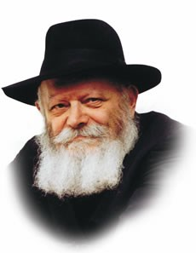

How does a person become a Jew? This week's Torah portion, Mishpatim, indirectly touches upon this question.

Historically, the Jewish people entered into the covenant of the Torah by performing three actions: brit mila (circumcision); immersion in a mikva; and the bringing of offerings, as it states, "And they offered burnt offerings, and sacrificed peace offerings of oxen unto G-d."

Ever since the Torah was given, a potential convert to Judaism had to undergo a conversion process consisting of these three steps. After the Holy Temple was destroyed and offerings could no longer be brought, a person became Jewish after brit mila and immersion alone.

When Moshiach is revealed and the sacrifices are reinstated, converts will again be required to bring an offering to the Holy Temple.

A question is raised: If, for the past 2,000 years of the exile, one of the necessary requirements for conversion has been absent, how can converts be considered fully Jewish?

The answer lies in the fundamental difference between the acts of brit mila and immersion, and the act of bringing an offering.

The first two actions effect an essential change in the person and transform him into a Jew, severing him from his past and imbuing him with a Jewish holiness. Bringing a sacrifice, on the other hand, merely enhances his relationship with G-d, rather than causing an essential change in his being.

As we learn from the Hebrew word for sacrifice, "korban," which implies "closeness" and "affinity," a sacrifice is a gift to G-d that strengthens the Jew's inner bond with his Father in Heaven. Thus, in the times of the Holy Temple, a convert brought his offering only after he had already become a Jew.

When the Holy Temple stood and the Divine Presence dwelt in a physical structure, the special relationship between the Jewish people and G-d was openly revealed. During the exile, however, with the physical Temple no longer in existence, it is much more difficult for the Jew to perceive the true magnitude of his bond with G-d. In such an atmosphere of concealment it is therefore possible to become a Jew even without the enhancement of a sacrifice.

The fact that converts will be required to bring a sacrifice when the Third Holy Temple is built does not mean that their conversions have been deficient in any way. The coming of Moshiach and the building of the Temple will in no way lessen the holiness of any Jew. Moreover, converts will be able to partake of the various sacrifices like any other Jew, even before their own individual offerings are brought.

*Reprinted from the 5756/2996 edition of L’Chaim Weekly. Adapted from Likutei Sichot of the Rebbe Vol. 3*

**A Fulfilled Dream: Converting to Judaism Despite Terminal Diagnosis**

**By [Sofya Sara Esther Tamarkin](https://www.chabad.org/search/keyword_cdo/kid/23400/jewish/Tamarkin-Sofya-Sara-Esther.htm" \o "Browse more articles by Tamarkin, Sofya Sara Esther)**

*“The world says, ‘Time is money.’ I say, ‘Time is life.’ ”*

— Rabbi Menachem Mendel Schneerson, the Lubavitcher Rebbe, to the father of Rabbi YY Jacobson, Gershon Jacobson, in 1985

Recently, I lost a very special person in my life, a woman who taught me the immeasurable value of every moment. I met Julia when I was 6 and she was 12 back in the former Soviet Union.

Julia was not born Jewish, but she made a conscious decision to convert. This commitment was particularly inspiring and challenging because throughout the process of conversion, Julia was fighting cancer. But neither weakness nor pain deterred her from her lifelong goal to join the Jewish people.

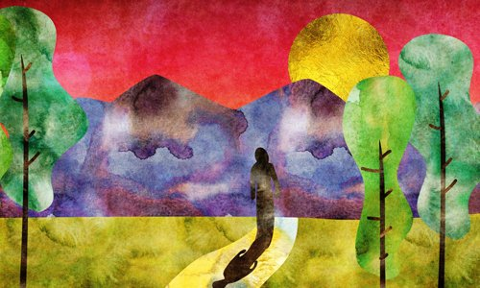

**Illustrated by Sefira Ross**

At one point, Julia made a decision to postpone chemotherapy in order to travel to Israel, a dream she knew she needed to fulfill. Together with her husband, she visited Jerusalem, the holiest place for the Jewish people, and became forever connected to our Land of Israel.

Both Julia and I were born in a city called Saratov on the Volga River. Growing up under the Communist regime, it was almost impossible to learn about any religious traditions and values. In 1987, Julia’s family immigrated to the United States, and in 1989, my family was welcomed by Julia’s family in America. After arriving in the United States, I started my own journey of reconnecting to my Jewish heritage. I have met many special people along the way, yet I have never known anyone so committed to the Jewish values and traditions.

Together with her husband, Leonid, who was born Jewish, Julia attended the Lubavitch Center for Russian Jewry for services and holiday celebrations. Rabbi Sholom Goldshmid spent countless hours teaching Torah ideas to her. Rebbetzin Malky Goldshmid and Julia became close friends. During Julia’s illness, Leonid often visited the Ohel in Queens, N.Y., the resting place of the Lubavitcher Rebbe, reading the entire book of Psalms for his wife. Julia felt an incredible connection to the Rebbe and read many of his teachings.

**Wasn’t Discouraged from Studying Torah by Her Illness**

Julia’s diagnosis didn’t discourage her from studying Torah, as well as learning and observing Jewish customs. She believed that each day offers an opportunity to get closer to G‑d, family and friends.

“Her faith in G‑d was total,” says Malky. “When she decided to convert to Judaism, she only looked forward. She had an absolute reliance on G‑d that whatever He does is for the good. As she said to the rabbi: ‘If G‑d has decided to take me at this time, I want to go as a Jew.’ ”

Any prognosis was irrelevant to her mission because she accepted one moment at a time and used it to bring light to the world. She was an exceptional mother who offered her two boys unconditional love and acceptance. When someone was impatient with another person, she simply said, “Everyone is different,” and reminded them to treat people with respect and dignity.

Right before the pandemic, in February of 2020, Julia passed her conversion exam, walked into the waters of the *mikvah* and emerged with a new name, Chava Chaya.

**Met Each Jewish Milestone with Zest, Commitment and Joy**

Chava Chaya met each milestone of the Jewish year with zest, commitment and joy. She celebrated all of the Jewish holidays except one; she passed away a few days before Chanukah. I was so broken that Chava Chaya didn’t get a chance to light the menorah and to experience this last holiday.

ThenI realized that perhaps she didn’t live long enough to light the physical candles because her life itself was a light for the Jewish people.

How beautiful it is to know that there are people in this world who are so dedicated to our heritage and faith that no obstacles can stand in their way. This was the story of my friend, Chava Chaya, who was a shining example of faith, goodness and love. She wanted nothing more than to live as a Jew. While she accomplished her dream to convert and kept the commandments for just nine months, she felt fulfilled knowing that she was leaving this world as a proud Jewish woman.

May the memory of Chava Chaya bat Abraham be a blessing to the Jewish people.

*Reprinted from the Parshat Mishpatim 5781 email of Chabad.Org Magazine.*